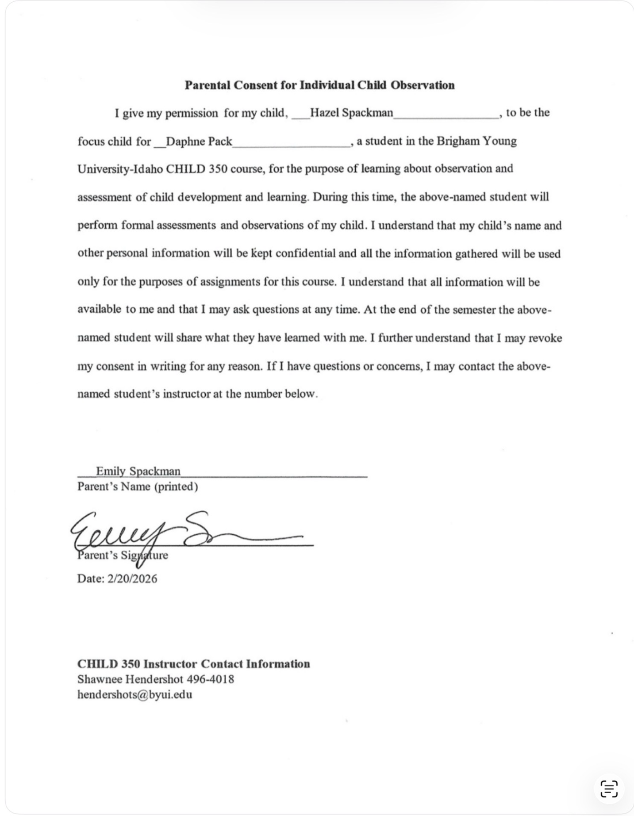

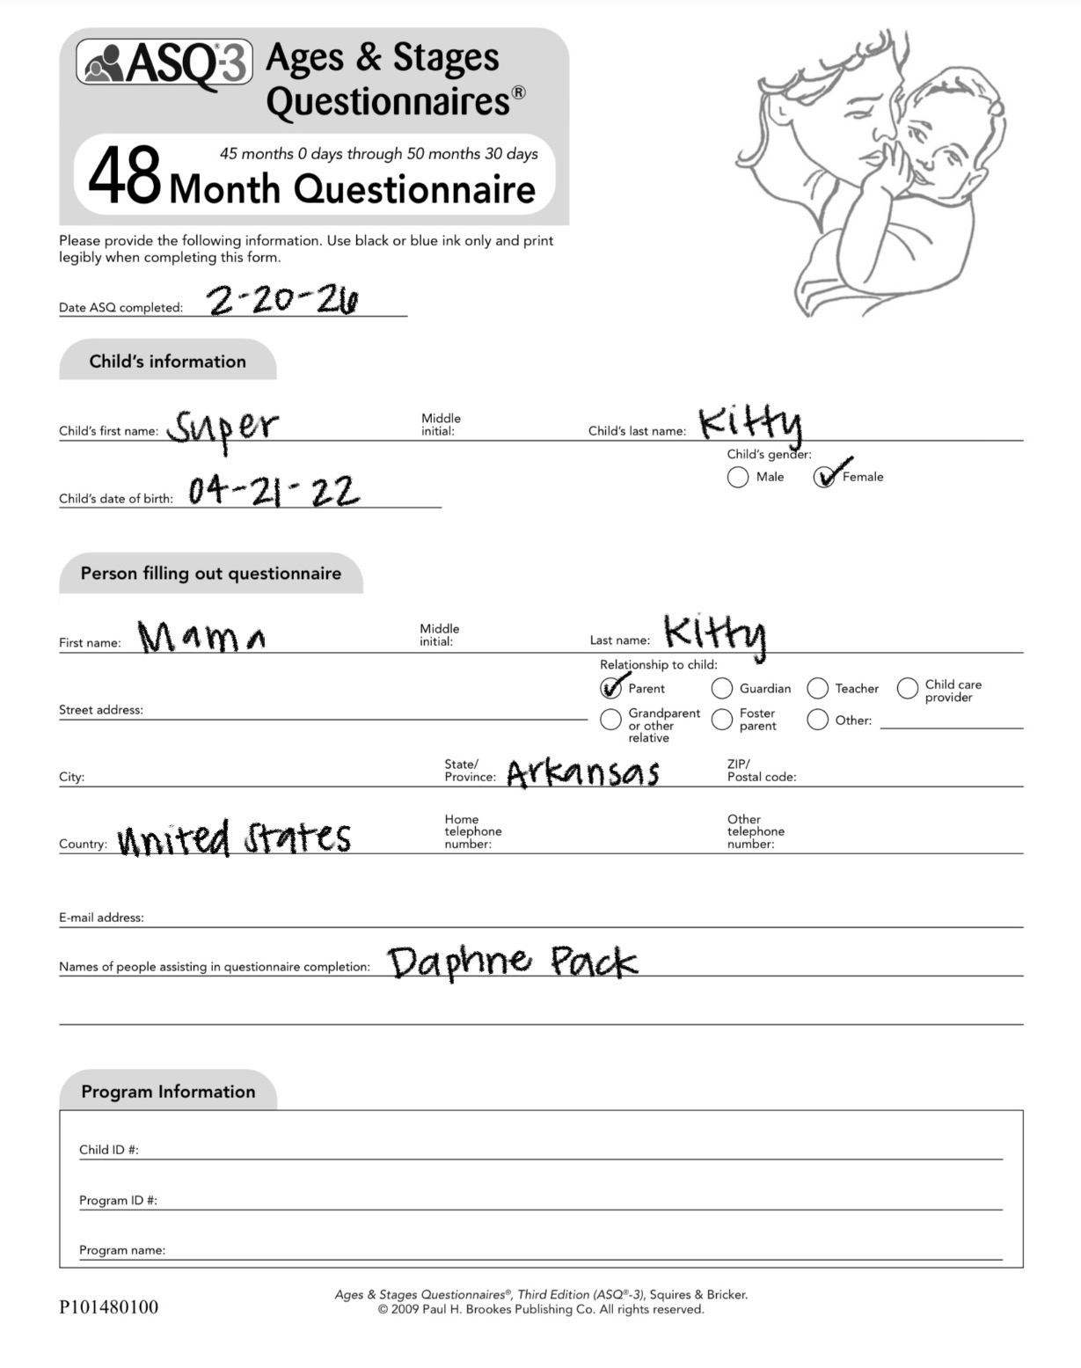

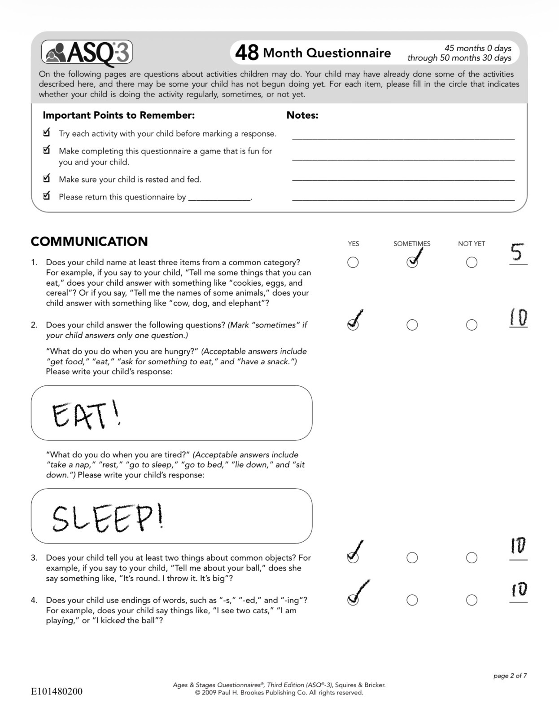

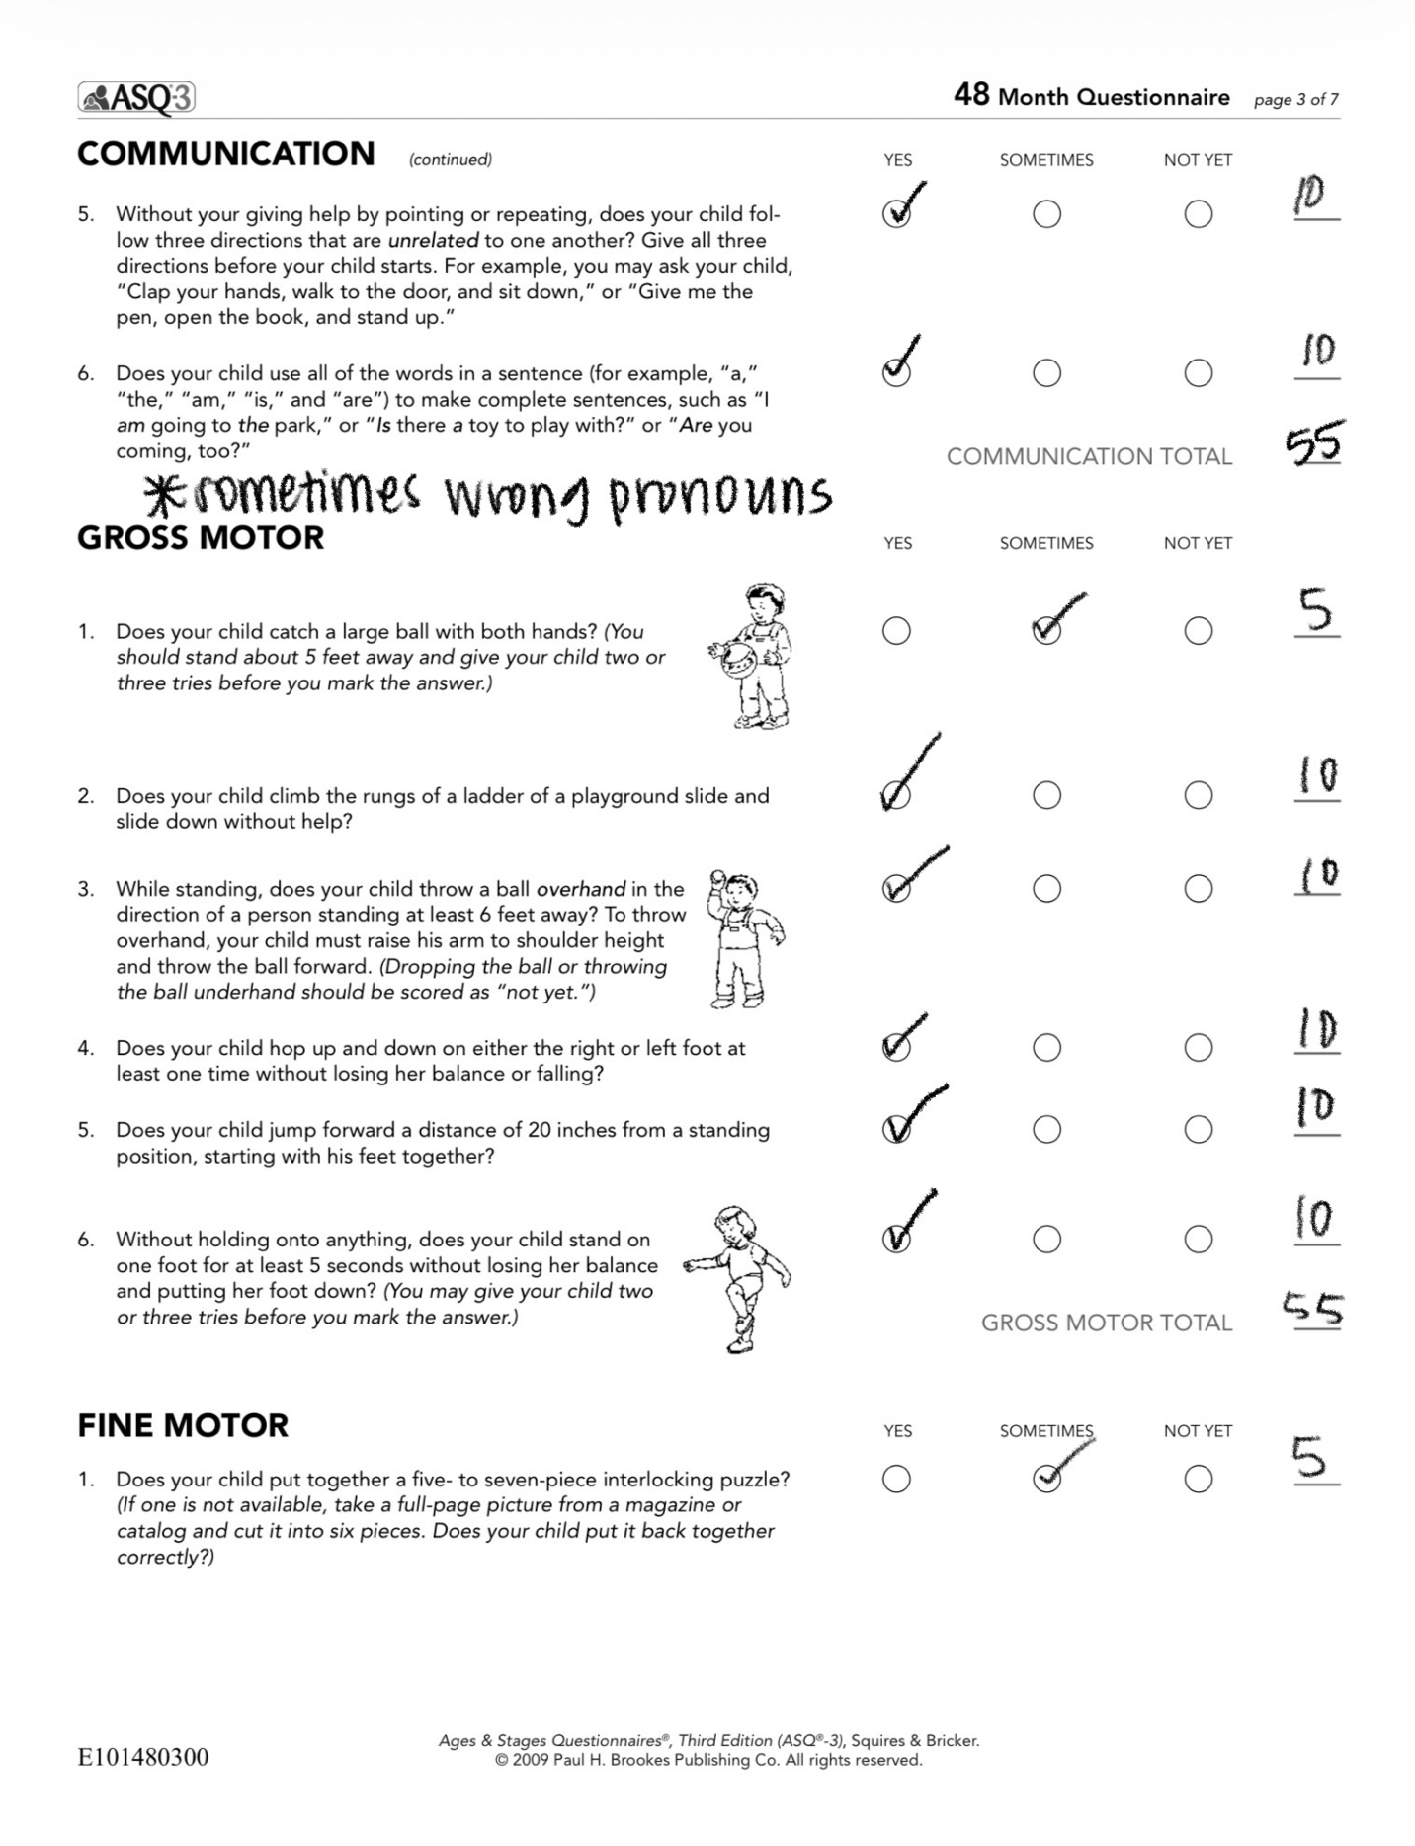

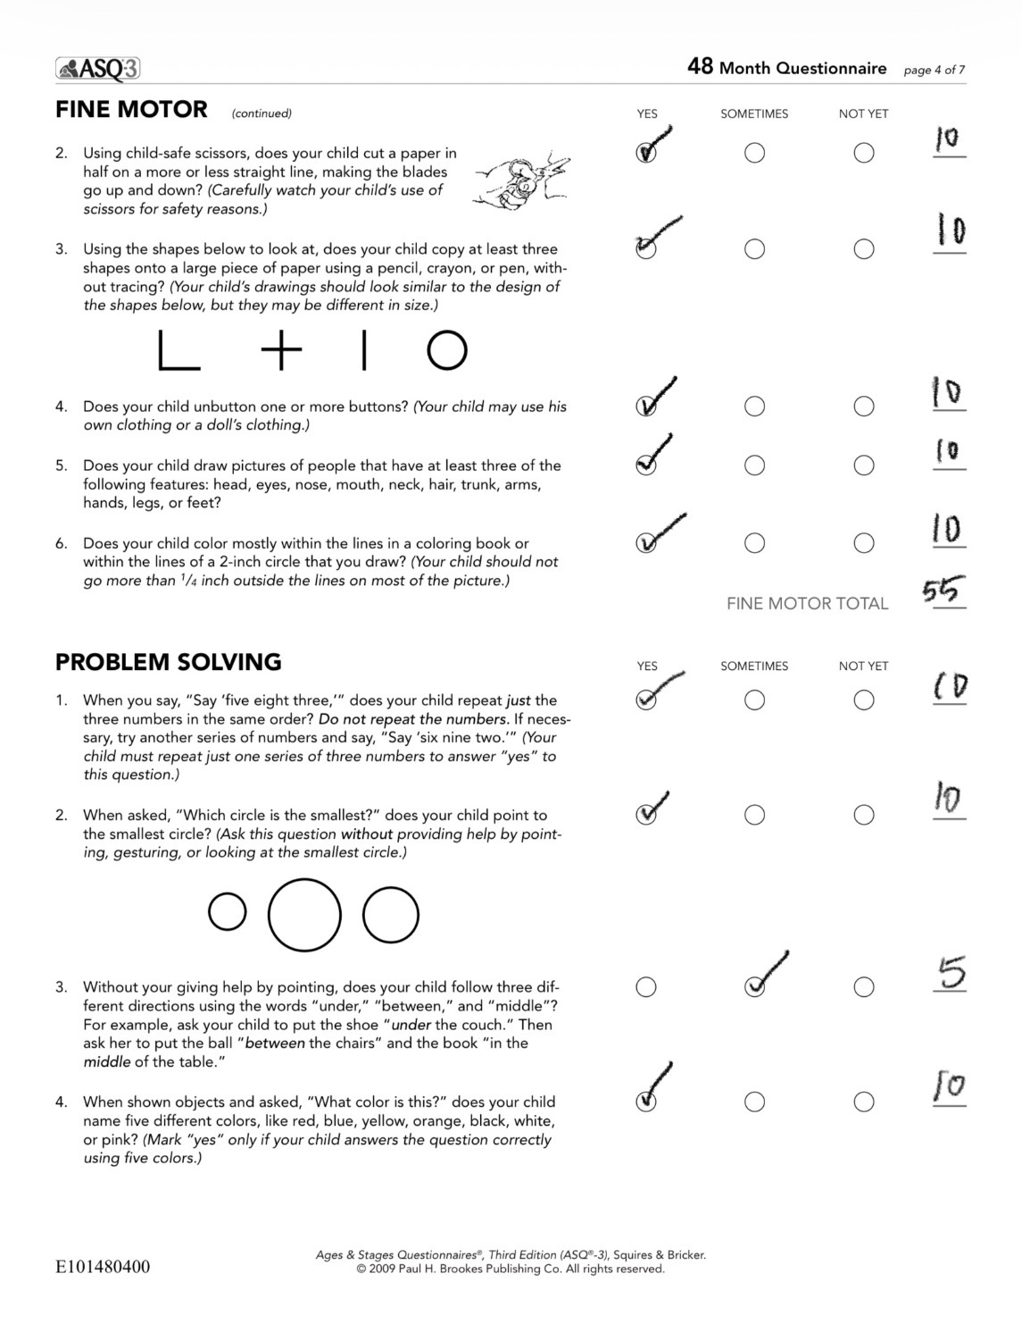

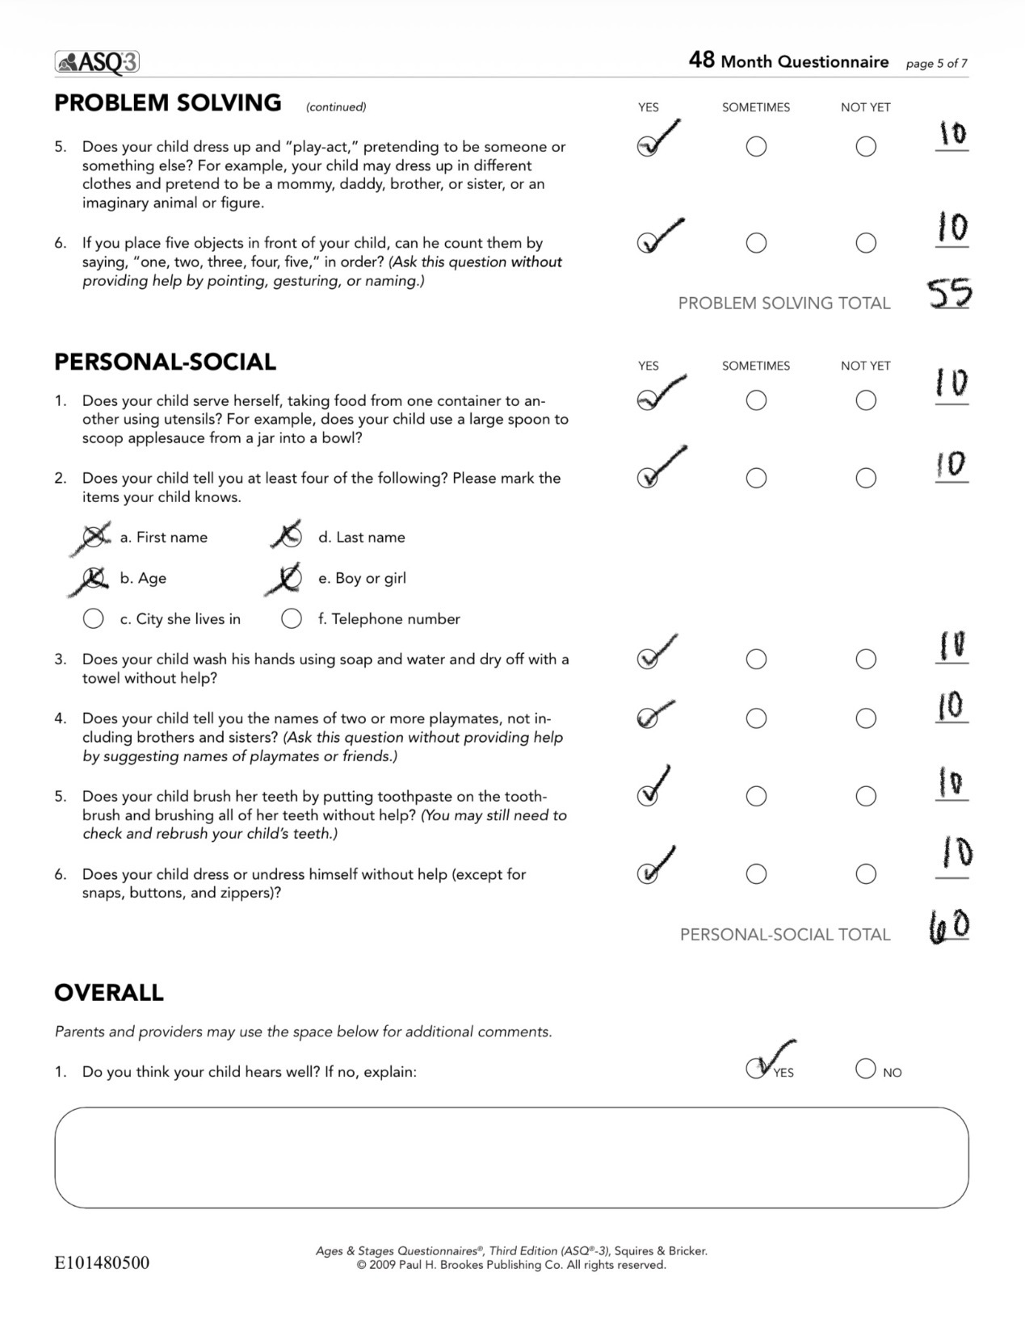

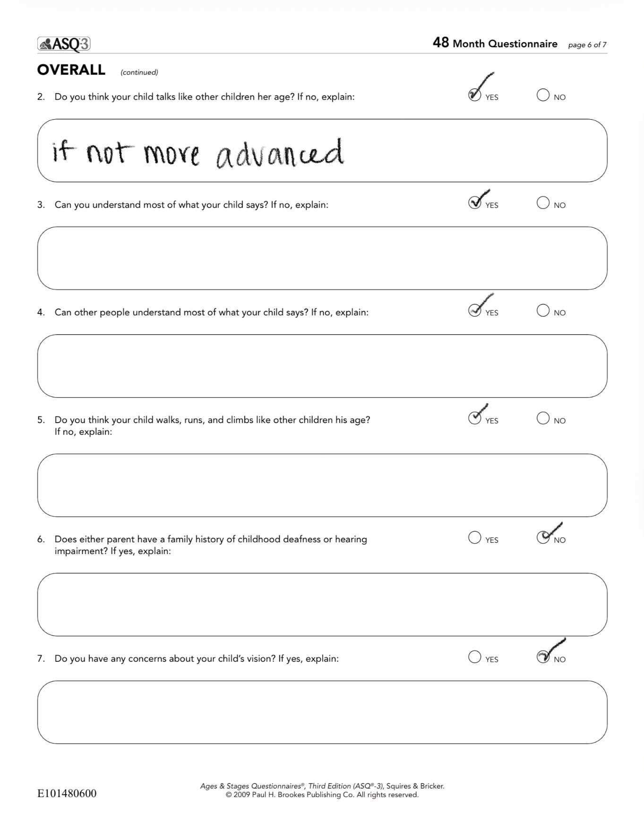

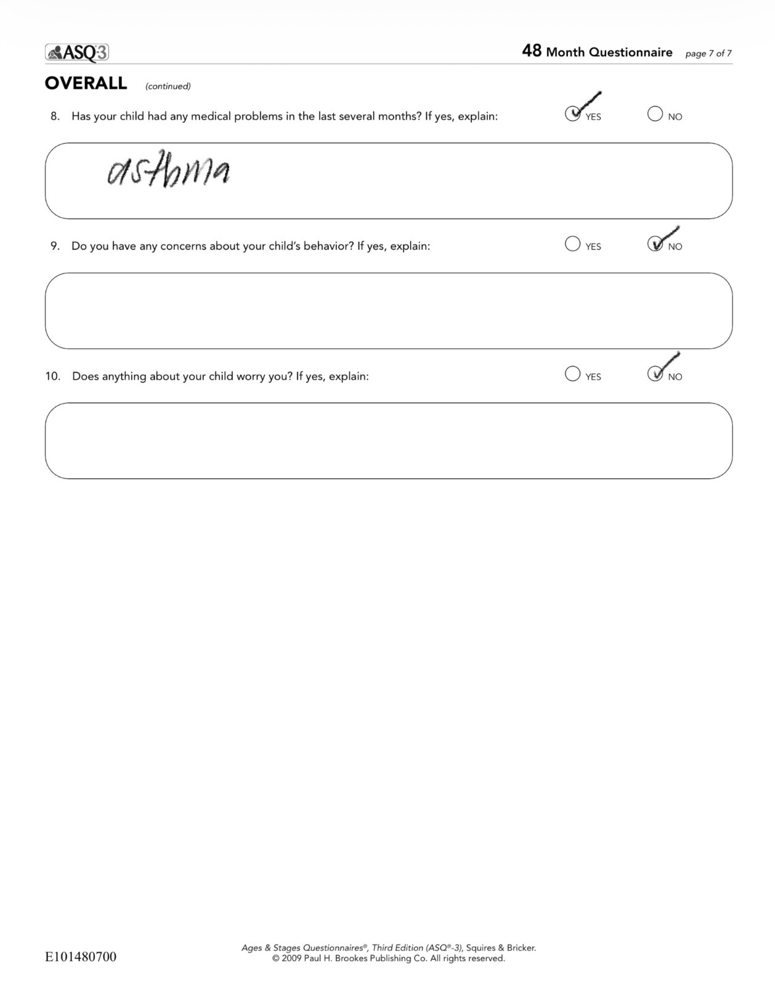

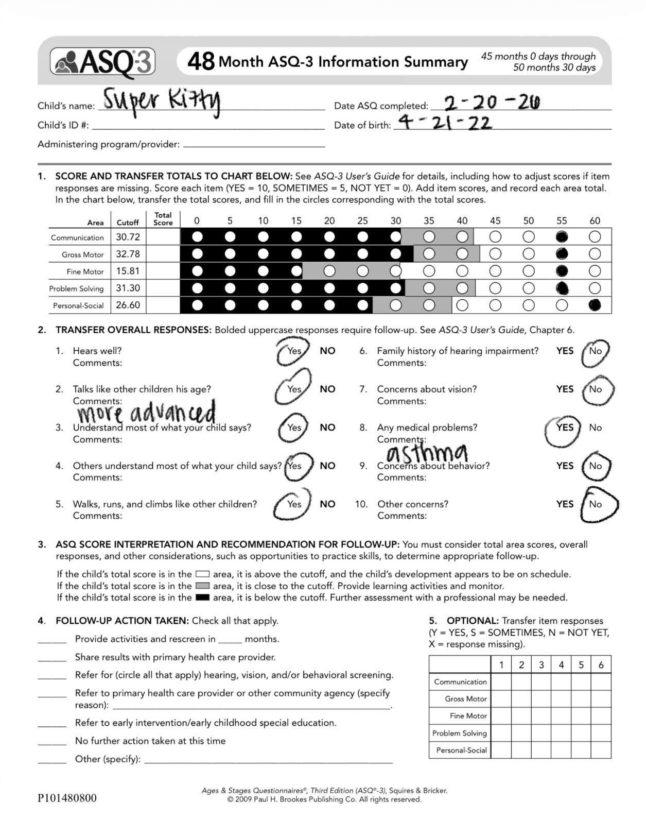

Suggested Learning Activity
Super Kitty scored highly in all the assessment categories. For the purpose of this assignment, I will suggest a learning activity that falls in the problem-solving area. While she already excels in her problem-solving abilities, I suggest that Super Kitty be given more opportunities to challenge herself in matching, specifically puzzles. Something I recommend her parents do is have her cut up a picture of something she is familiar with or likes with scissors, as she already enjoys doing, and challenge her to put it back together, perhaps with tape. Another way she can practice this skill is with simple 6–7-piece puzzles from the store, but by incorporating paper and scissors Super Kitty will have more intrinsic motivation to do the activity and thus get more out of it.

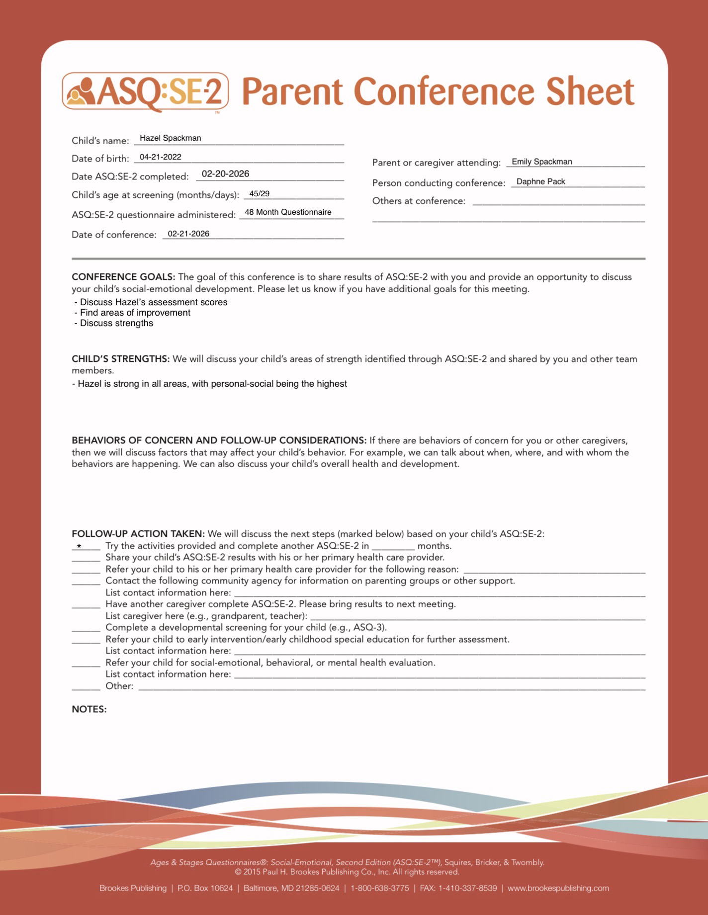

Parent Letter
Mama Kitty,
It was delightful meeting with you and your daughter! As we discussed in our conference, she is right on track in her development. Her biggest strength is her personal-social development, in which she received a perfect score. As a refresher, I encourage you to incorporate more puzzles or puzzle-like activities into your daughter’s play to foster her problem-solving skills. She is already doing very well in that area, but it can never hurt to improve and continue to support our children’s learning. I noticed how much she loved cutting with scissors and think she would have a lot of fun and learn a lot from cutting up pictures into pieces and putting them together again. Incorporating tape may be a little beyond her current ability, as you informed me, but I encourage you to let her practice sticking tape which will help with her fine motor skills as well. Thank you so much for your time and help!
Daphne Pack

